**Medical Store Module**

Medical store GUI and data extraction from RFID for medical store module by Ansari M.Saeem (2019430001)

**Parts which I worked on:**

When doctor prescribe any medicine to any petient it will save into one of the empty section in RFID. When pateint visit Medical store there will be a RFID reader he/she just need to tap and their request will go into queue which is maintain by our system. After tapping, RFID reader will read the medicine name and update the queue will is currently display to medical store guy. Once patient get the medicine and he/she pays for it they again tap the reader after second tap by same user will dequeue the request from queue which indicate that respective patient has been serve.

**Important classes and functions/Methods:**

MIFARE_Write() : This arduino function is used to write code in RFID and it is available in MIFARE library

jSerialComm : This library is used to make serial communication between java and arduino.

SerialReader(InputStream in) : This java method is used to read data from RFID.

**Screenshots:**

Data entry in RFID : As doctor prescribe and enter the name of medicine, the data will get store into one of the empty section in patient RFID as shown belove a patient name Saeem Ansari got a [prescription](https://www.google.com/search?client=ubuntu&hs=wOq&channel=fs&sxsrf=ALeKk01bA2ragEQN2gj6k6BugvyUiI-t-w:1586181961464&q=prescription&spell=1&sa=X&ved=2ahUKEwjWxPKi_NPoAhWp4HMBHYmeCzwQBSgAegQICxAn) of Paracetamol 180mg.

This screen shot is taken from MiFARE Classic Tool mobile app.

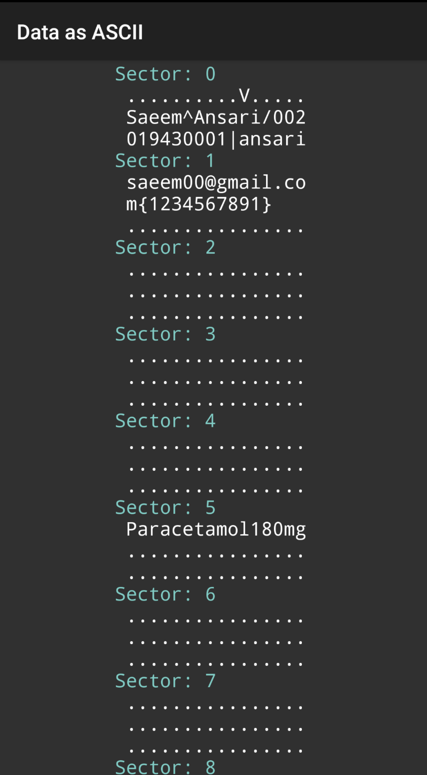

Queue before tapping : Here two patients (Shreyam Shah and Deepal Thakur) are already in the queue.

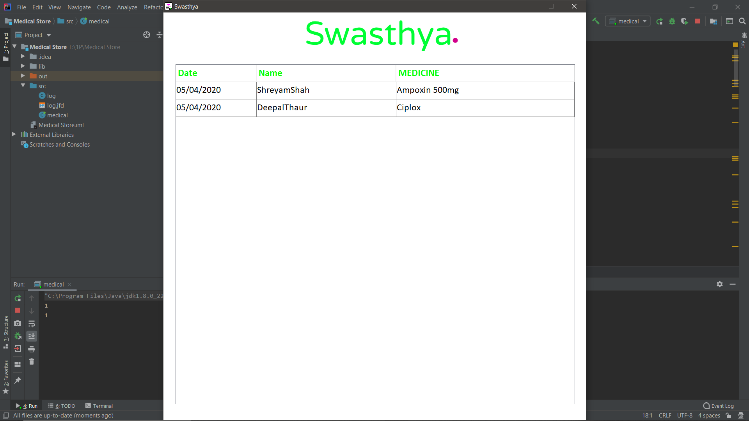

Queue after tapping : Here a patient name Saeem Ansari is tap the reader and his prescribed medicine goes to the queue.

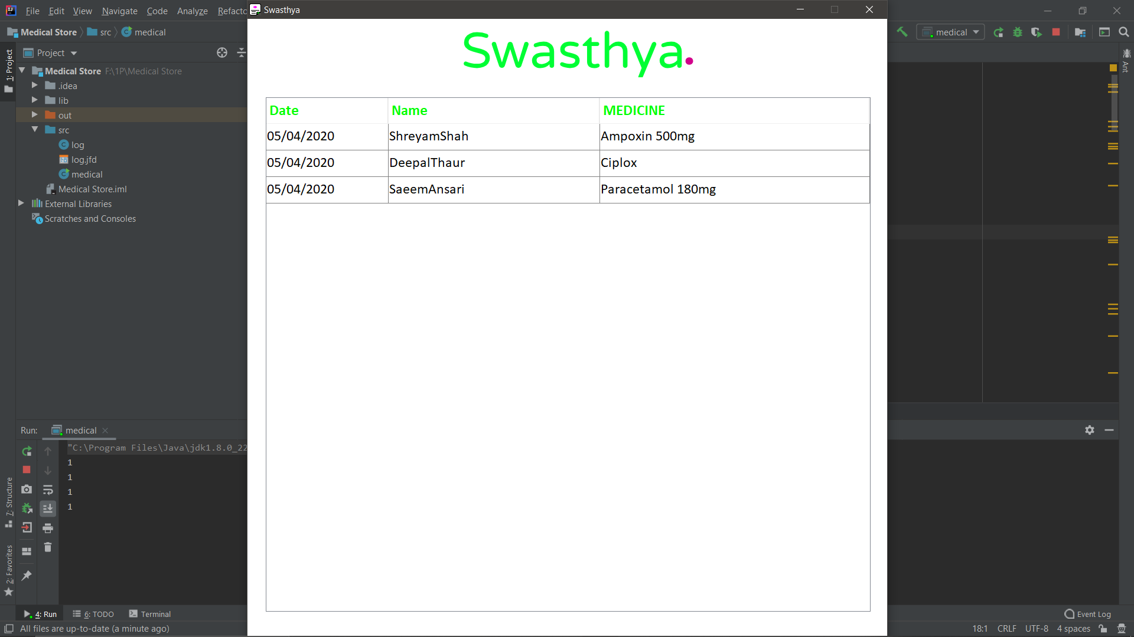

Queue after second tap : After completing the transaction saeem will again tapthe reader and his name will get deuqeue.

